Selenium Automation – 10 Test Cases

import time
from selenium import webdriver
from selenium.webdriver.common.by import By

driver = webdriver.Chrome() driver.get("https://www.saucedemo.com/inventory.html") driver.find_element(By.ID, "user-name").send_keys("standard_user") driver.find_element(By.ID, "password").send_keys("secret_sauce") driver.find_element(By.ID, "login-button").click()

A collection of 10 beginner-friendly Selenium WebDriver automation test cases written in Python. The examples cover website login, JavaScript alerts, mouse actions, drag-and-drop, and explicit waits.

Table of Contents

- Open Online Shopping Website
- Alert Accept
- Alert Dismiss
- Prompt Alert
- Mouse Hover
- Double Click
- Drag and Drop

- Explicit Wait
- Clickable Wait
- Alert Wait

Requirements

  - Python 3
  - Google Chrome
  - Selenium Python package Install Selenium:

python -m pip install selenium
Selenium Manager can manage the compatible ChromeDriver for current Selenium versions.

TC-1: Open Online Shopping Website

Test case: Customer opens the online shopping website and logs in.
Website: SauceDemo

import time
from selenium import webdriver
from selenium.webdriver.common.by import By

driver = webdriver.Chrome() driver.get("https://www.tutorialspoint.com/selenium/practice/alerts.php") driver.find_element(By.XPATH, "//button[@onclick='myDesk()']").click()

alert = driver.switch_to.alert
time.sleep(10) driver.quit()
Expected result: The user logs in and the inventory page is displayed.
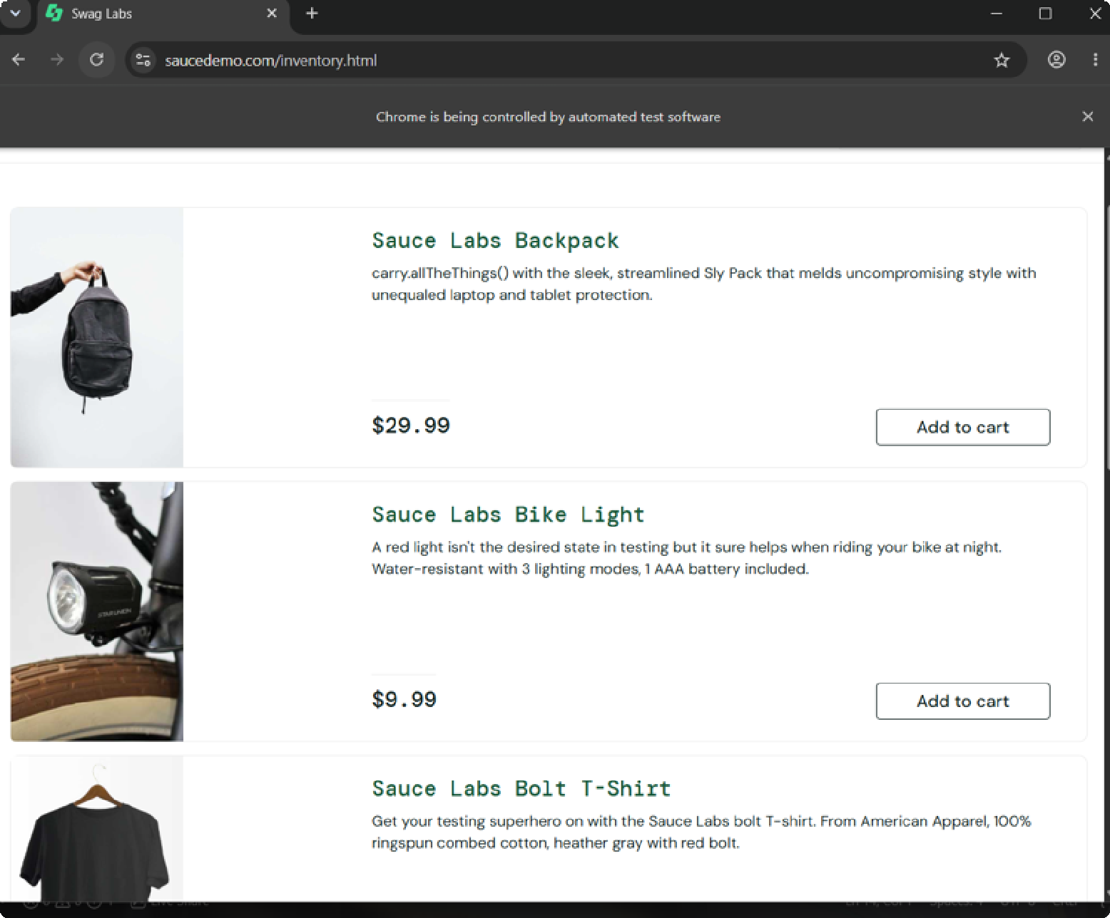

TC-2: Alert Accept

Test case: Customer clicks the alert button and accepts the confirmation popup.
Website: TutorialsPoint Alerts

import time
from selenium import webdriver
from selenium.webdriver.common.by import By

driver = webdriver.Chrome() driver.get("https://www.tutorialspoint.com/selenium/practice/alerts.php") driver.find_element(By.XPATH, "//button[@onclick='myDesk()']").click()

alert = driver.switch_to.alert
time.sleep(5) alert.accept() time.sleep(10) driver.quit()
Expected result: The alert is accepted and closed.
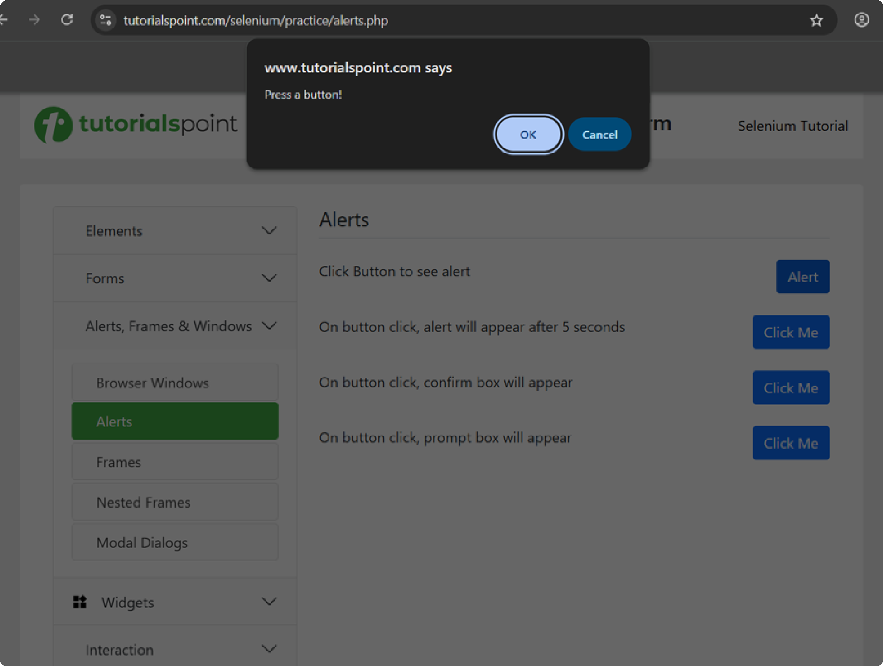

TC-3: Alert Dismiss

Test case: Customer clicks the alert button but chooses Cancel/dismiss.
Website: TutorialsPoint Alerts

import time
from selenium import webdriver
from selenium.webdriver.common.by import By

driver = webdriver.Chrome() driver.get("https://www.tutorialspoint.com/selenium/practice/alerts.php") driver.find_element(By.XPATH, "//button[@onclick='myPromp()']").click() time.sleep(1)
time.sleep(5) alert.dismiss() time.sleep(10) driver.quit()
Expected result: The alert is dismissed.
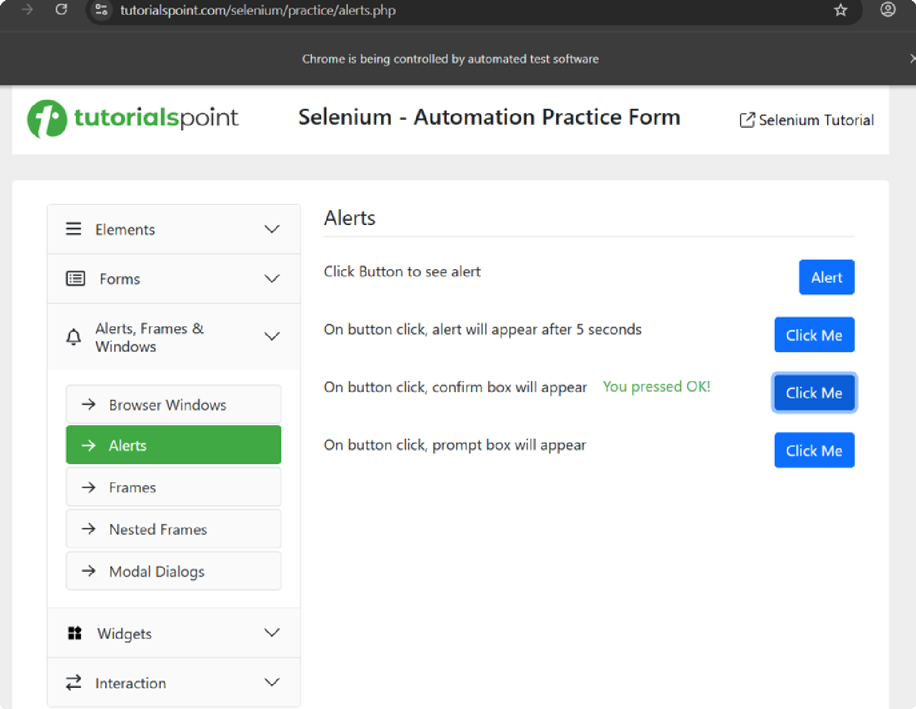

TC-4: Prompt Alert

Test case: Customer enters a name or other information in a prompt popup.
Website: TutorialsPoint Alerts

import time
from selenium import webdriver
from selenium.webdriver.common.by import By
from selenium.webdriver.common.action_chains import ActionChains

driver = webdriver.Chrome()
alert = driver.switch_to.alert alert.send_keys("DK") time.sleep(10)
alert.accept() time.sleep(2) driver.quit()

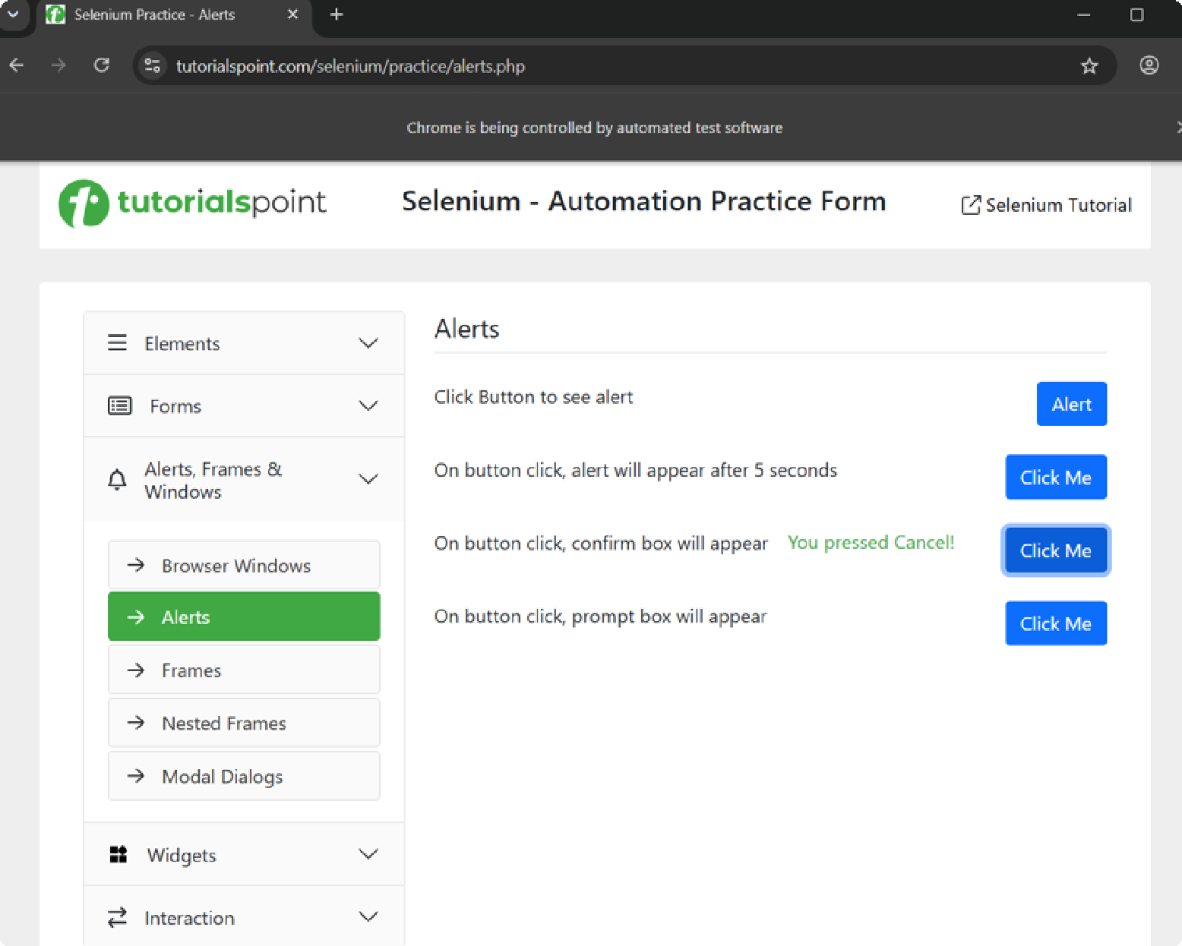
Expected result: The text DK is entered into the prompt and the prompt is accepted.

TC-5: Mouse Hover

Test case: Customer moves the mouse over a menu item to trigger its hover behavior.
Website: DemoQA Menu

import time
from selenium import webdriver
from selenium.webdriver.common.by import By
driver.get("https://demoqa.com/menu/") time.sleep(5)

menu = driver.find_element(By.XPATH, "//a[text()='Main Item 2']") actions = ActionChains(driver)
time.sleep(2)

actions.move_to_element(menu).perform() time.sleep(3)
driver.quit()
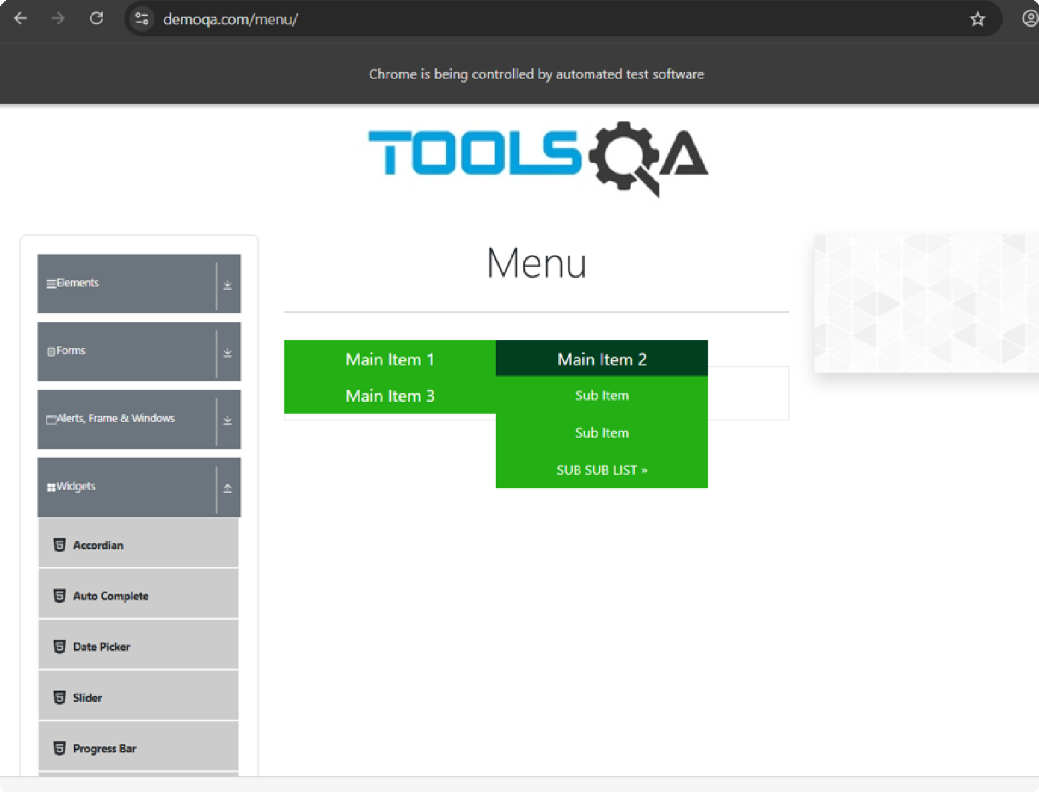
Expected result: The pointer hovers over Main Item 2 and its hover behavior is triggered.

TC-6: Double Click

Test case: Customer double-clicks a button.
Website: DemoQA Buttons

from selenium.webdriver.common.action_chains import ActionChains

driver = webdriver.Chrome() driver.get("https://demoqa.com/buttons") time.sleep(10)

button = driver.find_element(By.ID, "doubleClickBtn") ActionChains(driver).double_click(button).perform()

time.sleep(10) driver.quit()
Expected result: The double-click action is performed on the button.
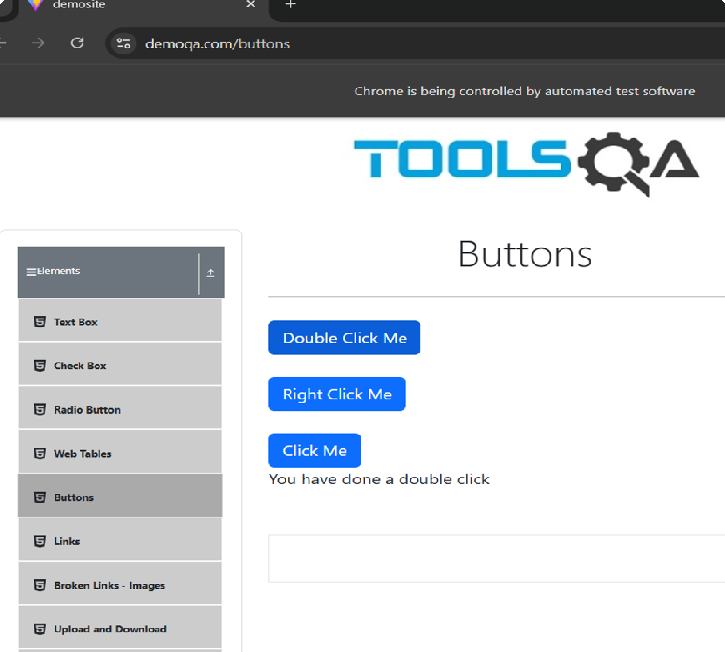

TC-7: Drag and Drop

Test case: Customer drags an item into a target area.

Website: DemoQA Droppable

import time
from selenium import webdriver
from selenium.webdriver.common.by import By
from selenium.webdriver.common.action_chains import ActionChains

driver = webdriver.Chrome() driver.get("https://demoqa.com/droppable") driver.maximize_window()

time.sleep(2)

source = driver.find_element(By.ID, "draggable") target = driver.find_element(By.ID, "droppable")

time.sleep(3)
actions = ActionChains(driver) actions.click_and_hold(source) actions.move_to_element(target) actions.release() actions.perform()

time.sleep(3) driver.quit()
Expected result: The draggable item is moved to the droppable target.
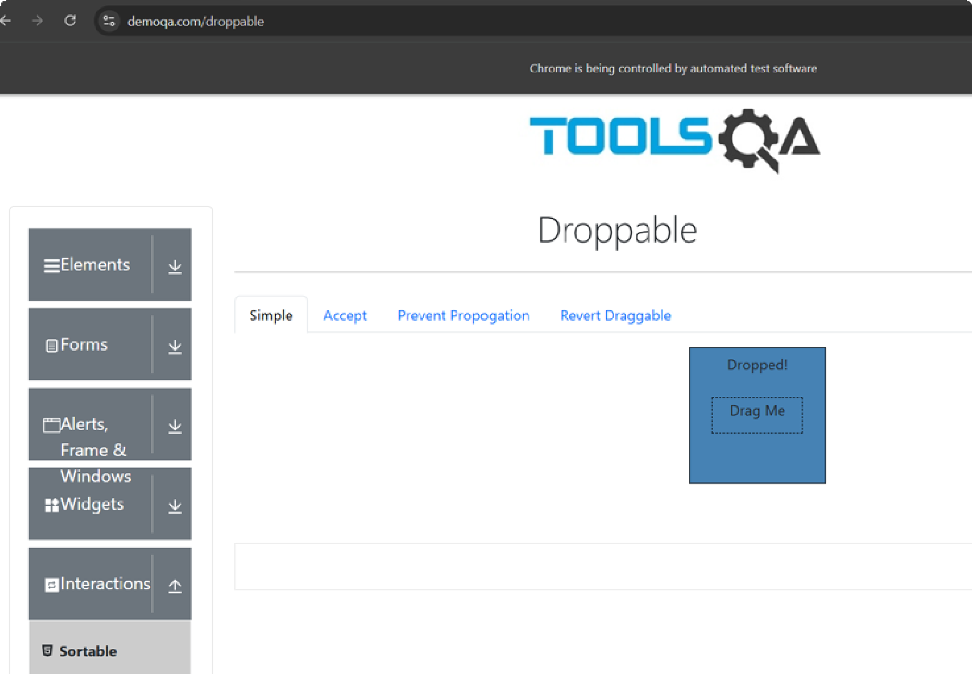

TC-8: Explicit Wait

Test case: Customer logs in and waits until a product becomes visible.
Website: SauceDemo

import time
from selenium import webdriver
from selenium.webdriver.common.by import By
from selenium.webdriver.support.ui import WebDriverWait
from selenium.webdriver.support import expected_conditions as EC

driver = webdriver.Chrome() driver.get("https://www.saucedemo.com/")

driver.find_element(By.ID, "user-name").send_keys("standard_user") driver.find_element(By.ID, "password").send_keys("secret_sauce") driver.find_element(By.ID, "login-button").click()

wait = WebDriverWait(driver, 10) product = wait.until(
EC.visibility_of_element_located(
(By.XPATH, "//div[text()='Sauce Labs Backpack']")
)
)
product.click()

time.sleep(10) driver.quit()

Expected result: Selenium waits up to 10 seconds for the product element to become visible, then clicks it.

import time
from selenium import webdriver
from selenium.webdriver.common.by import By
from selenium.webdriver.support.ui import WebDriverWait
from selenium.webdriver.support import expected_conditions as EC

driver = webdriver.Chrome() driver.get("https://www.saucedemo.com/")

driver.find_element(By.ID, "user-name").send_keys("standard_user") driver.find_element(By.ID, "password").send_keys("secret_sauce")
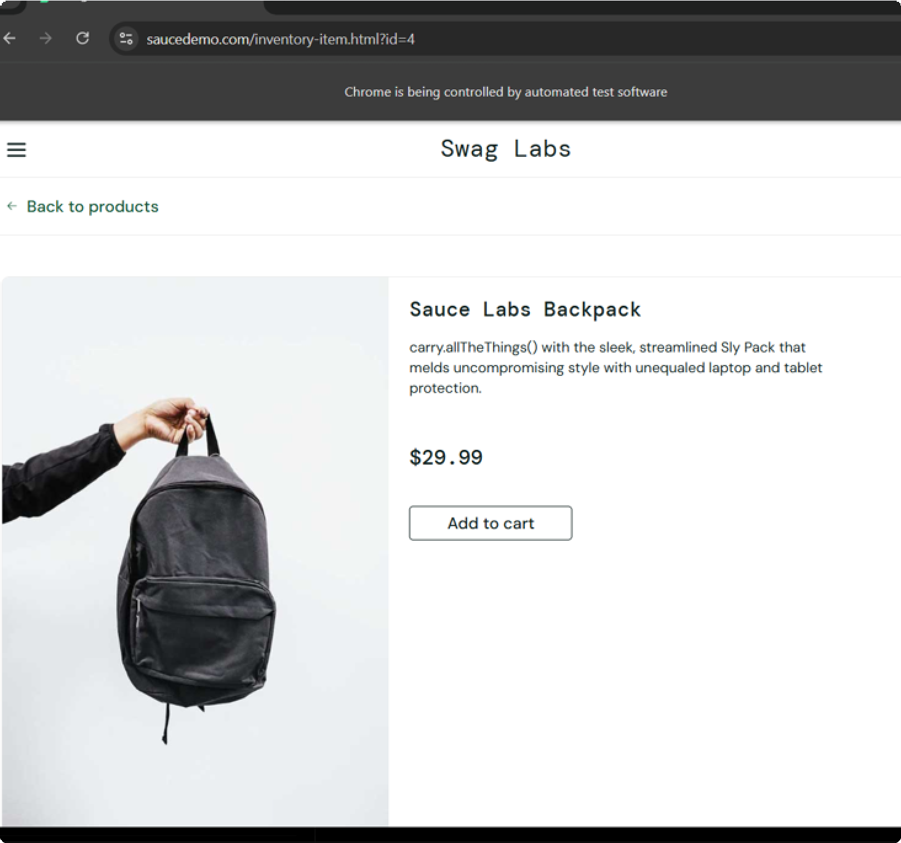

TC-9: Clickable Wait

Test case: Customer proceeds through checkout and waits until the Finish button is clickable.
Website: SauceDemo

driver.find_element(By.ID, "login-button").click()

driver.find_element(By.ID, "add-to-cart-sauce-labs-backpack").click() driver.find_element(By.CLASS_NAME, "shopping_cart_link").click() driver.find_element(By.ID, "checkout").click()

time.sleep(5)

driver.find_element(By.ID, "first-name").send_keys("DK") driver.find_element(By.ID, "last-name").send_keys("Test") driver.find_element(By.ID, "postal-code").send_keys("600001")

driver.find_element(By.ID, "continue").click()

wait = WebDriverWait(driver, 10) finish_button = wait.until(
EC.element_to_be_clickable((By.ID, "finish"))
)
finish_button.click()

time.sleep(2) driver.quit()
Expected result: Selenium waits until the Finish button is clickable, then clicks it to complete the checkout flow.
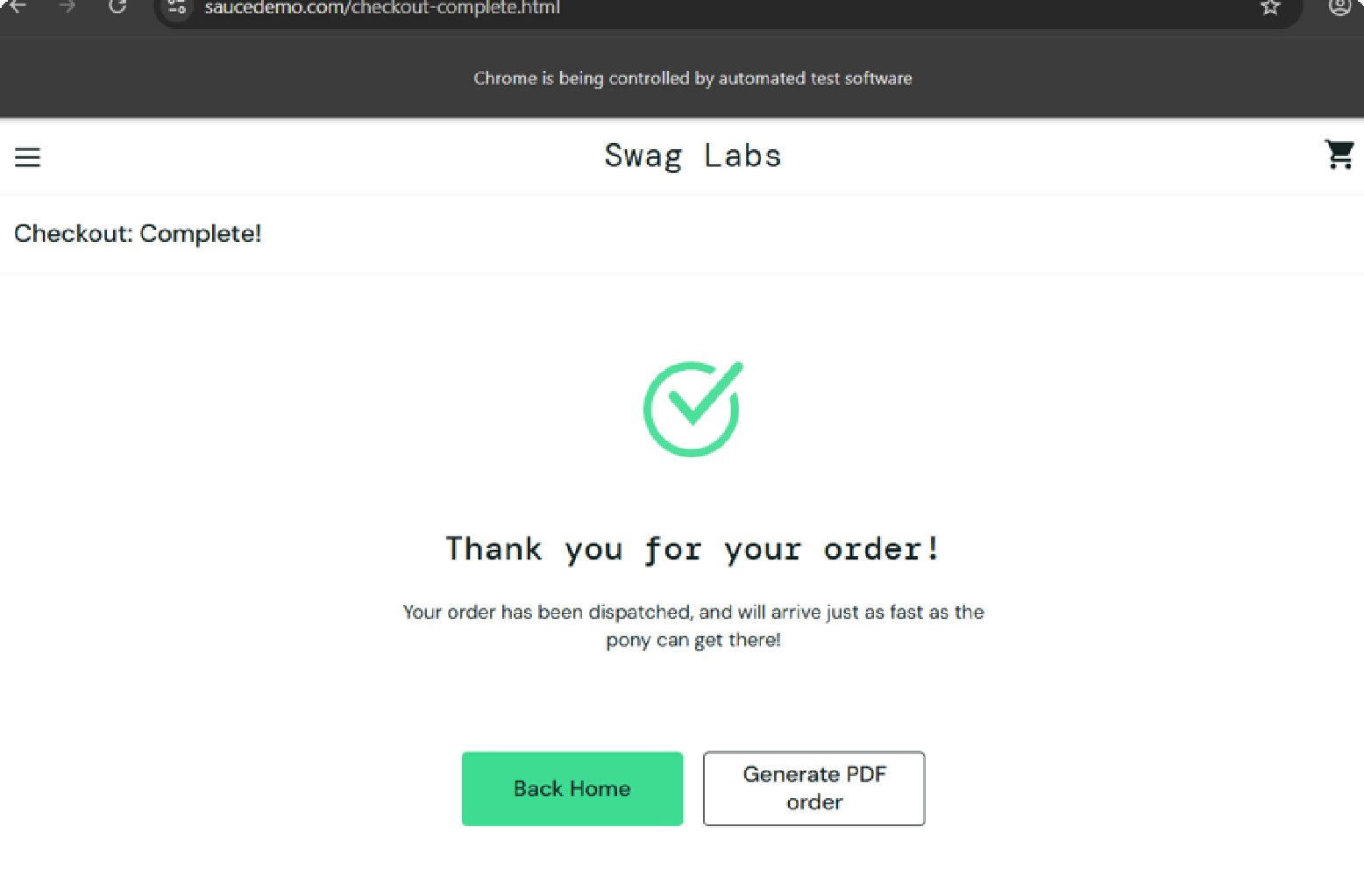

TC-10: Alert Wait

Test case: Customer triggers an alert and waits until the alert popup is present.
Website: TutorialsPoint Alerts

import time
from selenium import webdriver
from selenium.webdriver.common.by import By
from selenium.webdriver.support.ui import WebDriverWait
from selenium.webdriver.support import expected_conditions as EC

driver = webdriver.Chrome() driver.get("https://www.tutorialspoint.com/selenium/practice/alerts.php")

driver.find_element(By.XPATH, "//button[@onclick='myMessage()']").click()

wait = WebDriverWait(driver, 10)
alert = wait.until(EC.alert_is_present())

time.sleep(5) alert.accept() time.sleep(5) driver.quit()
Expected result: Selenium waits up to 10 seconds for the alert to appear and then accepts it.
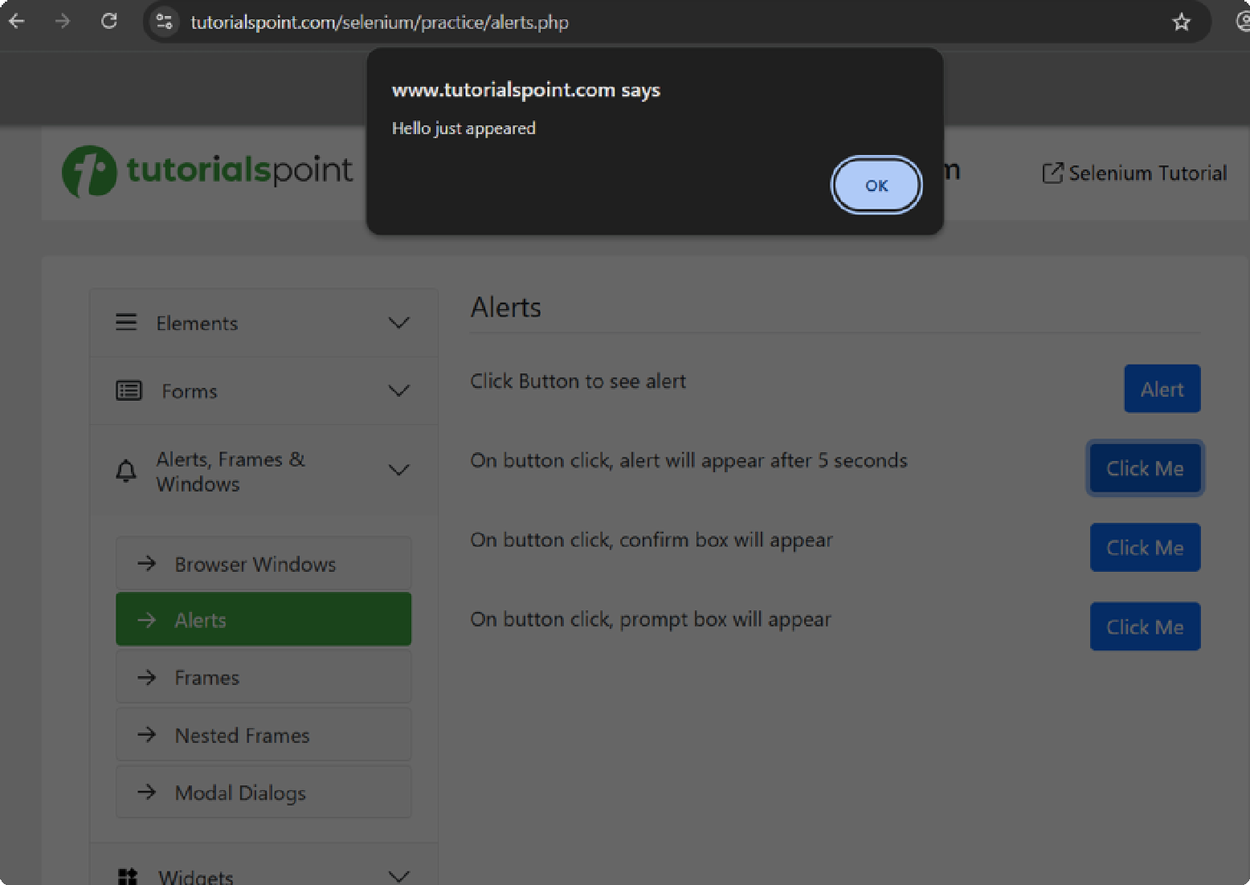

Concepts Covered

- Opening websites and locating elements with Selenium
- Locators: ,
By.ID
By.XPATH
, and By.CLASS_NAME
with accept() , dismiss() ActionChains
send_keys()

- Handling JavaScript alerts
- Mouse interactions using
- Drag-and-drop interactions
- Explicit waits using
WebDriverWait

and
, and

- Waiting for visibility, clickability, and alert presence
expected_conditions

